BARGO WASTE MANAGEMENT CENTRE
POLLUTION INCIDENT RESPONSE MANAGEMENT PLAN
2016
Trim 1807#1549
Reviewed Monday 22 January 2016 by John Ghassibe of J & C Facilities and Dan Meehan Wollondilly Shire Council

1.0 Pollution Incident - DEFINITION

i) A pollution incident means an incident or set of circumstance during or as a consequence of which there is or is likely to be a leak, spill or other escape or deposit of a substance, as a result of which pollution has occurred, is occurring or is likely to occur.

ii) It includes an incident or set of circumstances in which a substance has been placed or disposed of on premises, but does not include an incident or set of circumstances involving only the emission of any noise.

2.0 Need to Notify

The Contractor shall immediately notify Council of a pollution incident if there is a risk of ‘material harm to the environment’, which is defined in section 147 of the POEO Act as:

(a) Harm to the environment is material if:

(1) it involves actual or potential harm to the health or safety of human beings or to ecosystems that is not trivial, or
(2) it results in actual or potential loss to property damage of an amount, or amounts in aggregate, exceeding $10,000 (or such other amount as is prescribed by the regulations), and

(b) Loss includes the reasonable costs and expenses that would be incurred in taking all reasonable and practical measures to prevent, mitigate or make good harm to the environment.

(c)Hazards to human health and the environment identified at premises

(1) Fire

Three types of fires may occur at Bargo Waste Management Centre (BWMC)
Type 1 Fire in unprocessed vegetation
Type 2 Fire in garden oragnics
Type 3 Fire in landfill

Each fire will create smoke. The fire can potentially escape from the site to adjoining bushland.

(2) Landslip

The BWMC has steep slopes on the eastern side in the vicinity of a water course – Dog Trap Creek. If a significant land slip occurred pollution would occur.

(3) Used motor oil

Domestic quantities of used engine oil are received and placed in two 1,000 Litre oil storage tanks

3.0 Likelihood of Hazards Occurring

(1) Fire

The most recent fire at the BWMC occurred during 2004. Fires are more likely to occur during times of high temperatures and wind.

(2) Landslip

One recorded landslip has occurred at the BWMC in 2005 during a major rain event. The surface water flowed over the edge of the landfill causing erosion and a minor landslip.

The construction of a new surface water treatment pond and changes to the contours at the Centre have reduced the likelihood of a future landslip occurring. No further landslips have occurred since 2005

(3) Used motor oil

No spillage of the oil stored in the two tanks has occurred

4.0 Pre-emptive action to minimize or prevent the risk of harm to human health or the environment

(1) Fire

(a) Type 1 Fire in stockpiled un-processed garden organics
- This garden organics is placed in a cleared area a minimum of 50 m from the edge of the site.
- The quantity of material is limited to approximately 2,000m3 before processing.
- A serviceable fire tanker is to be kept of site containing approximately 6,000 Litres of water as well as a 30,000 Litre water storage tank.

(b)Type 2 Fire in processed garden organics

- Pasteurizing organic windrows are located at the top of the landfill in a specially prepared clay lined and bunded site.
- Windrows are visually examined daily to ascertain if any signs of ignition is occurring (ie smoke).
- A serviceable fire tanker is kept on site containing approximately 6,000 Litres of water as well as a 30,000 Litre water storage tank.

(c) Type 3 Fire in landfill

- Landfilled material covered with 150 mm of soil or an approved alternate cover system after each days filling.
- A serviceable fire tanker is kept of site containing approximately 6,000 Litres of water as well as a 30,000 Litre water storage tank.

(2) Landslip
- Surface water to be directed away for eastern edge of the site to stormwater collection ponds.
- Access road provided around the eastern elevation of the site to enable inspections for any early side slope movement.
- Inspections to be carried out at the side slope following heavy or prolonged rain storms.

(3) Used motor oil
- Two x 1,000 Litre used engine oil storage tank have been inserted in a metal container to prevent any major oil leak from occurring.

- Inventory of potential pollutants at the premises

(a) Hazardous chemicals and asbestos cement products are not accepted at the BWMC.

(b) Used motor oil collection

Used motor engine oil stored in two x 1,000 Litre storage tanks located near the site entry.

6.0 Quantity of potential pollutants
(a) Used motor oil collection

A maximum of 2,000 Litres of used motor engine oil is located on the premises.

7.0 Safety equipment or other devices used to minimize the risks to human health or the environment or control a pollution incident

(a) Fire

i) A 6,000litre water storage tanker is kept permanently on site with approximately 6,000 Litres of water for use in the event of a fire as well as a 30,000 Litre water storage tank.

ii) Three portable fire extinguishers are also kept on the premises.

iii) The cleared crown land at the northern section of the landfill to be kept clear of regrowth vegetation to act as a fire break and a clearance during bush fires. (subject to Crown Lands approval)

(b) Landslip

i) A surface water pond has been installed and drainage channels constructed to ensure surface water does not travel over edge of landfill.

ii) A road has been constructed along the eastern elevation to enable inspections of the side slope for early signs of land slip.

(c) Used motor oil

i) The two x 1,000 Litre oil storage tanks are contained in a separate metal container to prevent any major oil leak from occurring.

8.0 Key person contact details

- Centre Attendants - Authorised to activate the plan
  - Bob Quinn 0419 490599
  - Andrew Kerin 0419 490599

- Operations Contractor - Authorised to notify responsible authorities
  - John Ghassibe 0417 282740 / 4683 1287

- Wollondilly Shire Council
Manager Environmental Service – Authorised to contact responsible authorities and to manage the response to the pollution incident.
  - Brad Staggs 0417 258159 / 46771100 / 4681051
- Regulatory Authority
EPA – Environment Line 131555

- Local Authority
Wollondilly Shire Council – Manager Environmental Services 0417 258159

- Ministry of Health - Local Public Health Unit
Camperdown SSW PHU 95159420 after hours 95156111

- Work Cover Authority 13 10 50

- Fire and Rescue 000

9.0 Mechanism for Early Warning and regulate updates to owners and occupiers of premises in vicinity to Bargo WMC

(1) Fire
i) In the event of a fire at the BWMC following immediate contact with each relevant authority the occupiers of the 95 Ironbarks Road Bargo and 125 Anthony Road Bargo will be notified as soon as practical.

ii) The notification will either be in the form of attendance at the properties and/or the leaving of a note in the properties mail box.

iii) Updates will be provided to the occupiers until the risk of an extended fire event is eliminated.

10.0 Arrangement to minimize risk of harm to people at premises

(1) Fire

Type 1 Fire in unprocessed vegetation
i) Members of public on the premises will be requested to leave.
ii) Public access to the landfill will be prevented until the fire in the unprocessed vegetation is brought under control and it is safe for re-entry to commence.

Type 2 Fire in Garden Organics
i) Public access to the site will only be permitted when no danger from flame or smoke exists.
ii) It is anticipated that fires in garden organics will be isolated to windrows the risk of harm is lower than a Type 1 fire.

Type 3 Fire in landfill
i) The public will not be permitted to deposit material in the section of the landfill burning.
ii) When no flame or smoke hazard exists the public will be permitted to deposit material in an area of the landfill isolated from the area burning.

2) Landslip
i) The public will not be permitted in any section of the landfill that has been affected by any landslip.

3) Used motor oil
i) The public will not be permitted in any section of the landfill affected by any oil spillage

11.0 Detailed map of premises and surrounding area
Map of premises

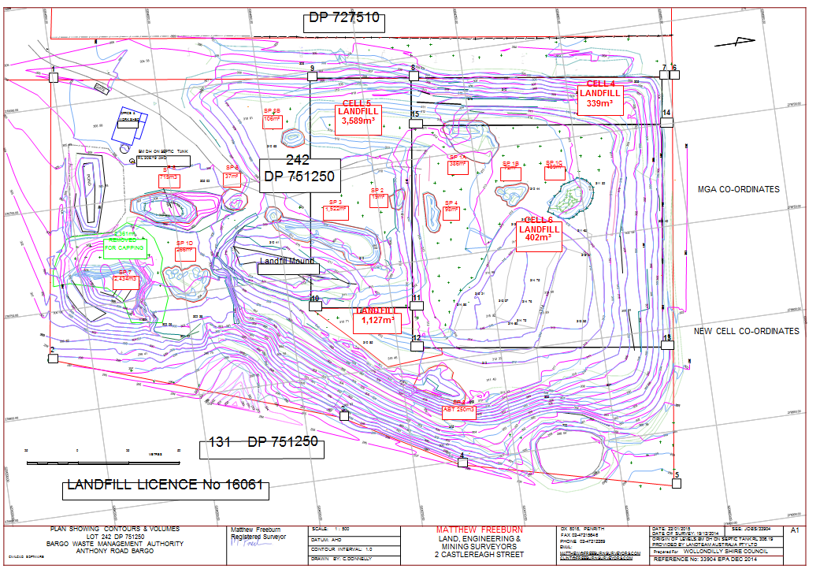

12.0 Other Maps
MAPS OF SURROUNDING AREA
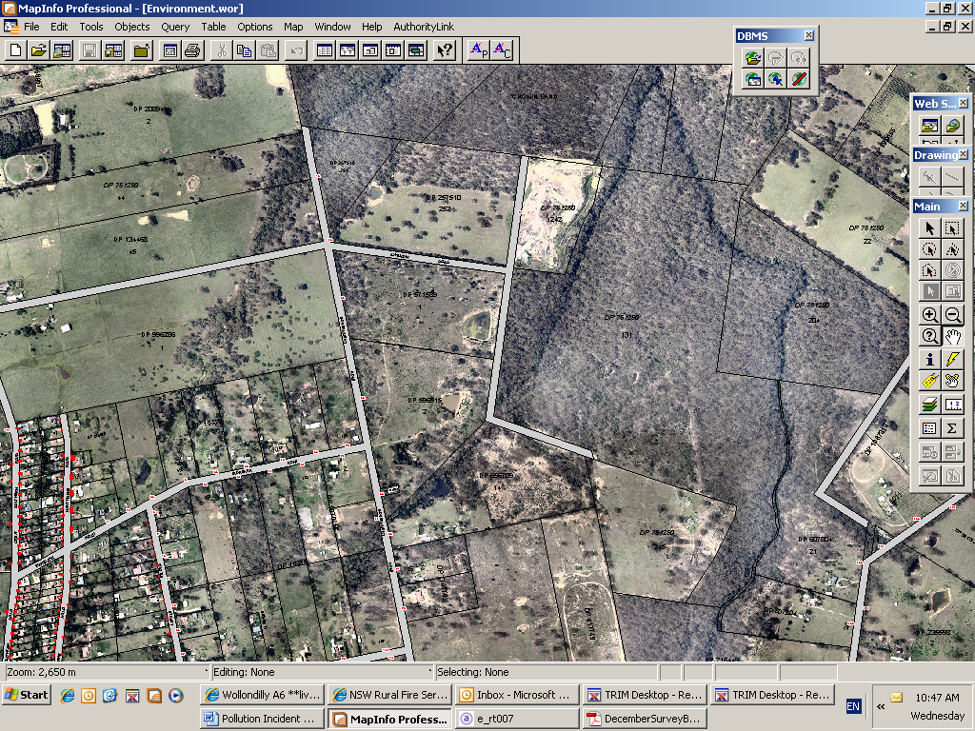
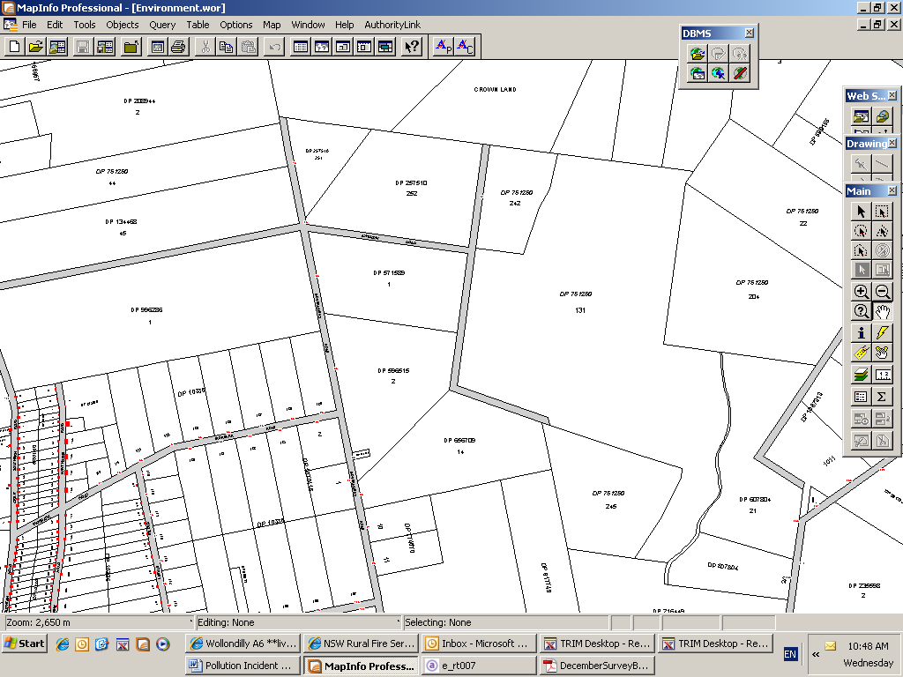

Landfill = Lot 242 DP 751250 Anthony Road Bargo + closed road
Nearest property = Lot 125 DP 10336 Number 95 Ironbarks Road Bargo
Other property = Lot 245 DP 751250 125 Anthony Road Bargo

Testing Points

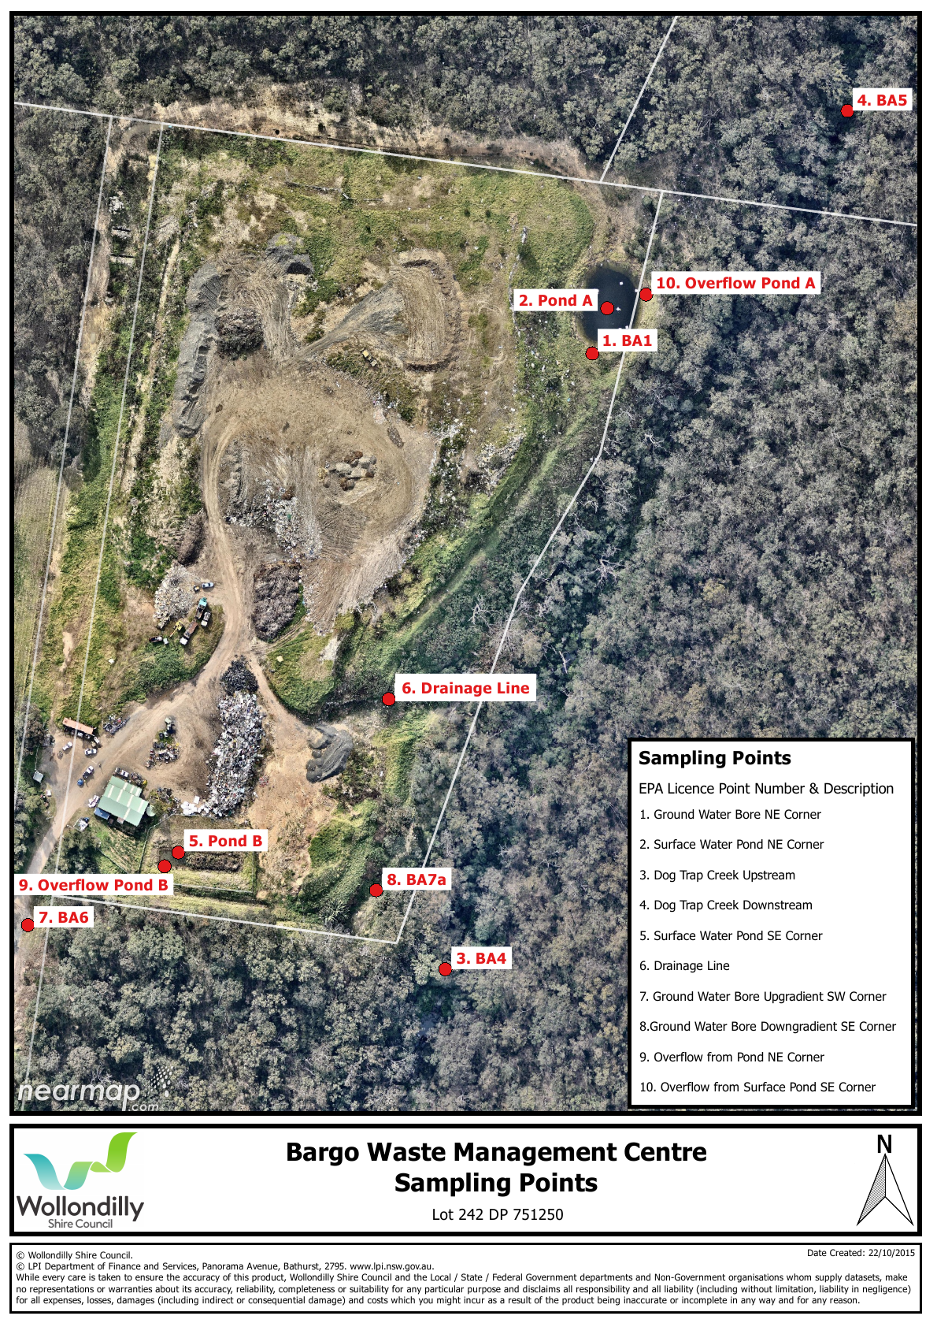
13.0 Risk of harm limitation
1) Fire
Summer Season
i) Vegetation within 50 m of the areas used for garden organics storage and processing will be removed and a fire break provided in the vicinity of the landfill cell.
ii) The water tanker will be serviced and trialed to ensure vehicle fully operational
iii) Vegetation piles of non-processed material to be reduced to a minimum.
iv) Material landfilled to be covered on a daily basis with 150mm soil or an approved alternate cover system while intermediate cover of 300 mm to be provided to areas to be exposed for more than 90 days.
v) Discussion will occur with officers from the NSW Rural Fire Service and any recommendations carried out each year before the fire season commences.

2) Landslip
i) Surface water drainage channels to be maintained so as to ensure water transfer to surface water dams.
ii) Regular inspections of eastern side slope to be carried out to detect any early evidence of ground movement following rain events

3) Used motor oil
i) Oil storage tanks to be emptied when 90% full and metal outer container to be maintained to ensure waste oil does not flow on to the ground.
ii) Emptying of the oil tanks to be undertaken in a responsible manner to avoid any oil spillages.

14.0 Training
i) PRMP training of Gate / Tip Attendants to be undertaken when staff first engaged as part of overall induction program.
ii) Training updates of existing staff must be carried out every 12 months during May.
iii) Training to include all matters documented in the PRMP.
iv) Tip Attendant to sign a copy of the plan certifying that the training has taken place with the signed copy forwarded to Council.
v) Operation Contractor to be trained when engaged.
vi) The issue of pollution responses to be a permanent agenda item at the Bargo Waste Management Centre Contract Meetings.
vii) Initial training of Operations Contractor undertaken on 26/6/2012
viii) Updated training of Operations Contractor each May (2013, 2014, 2015 & 2016)

15.0 Plan Training Date

i) The annual Training will be undertaken by the J & C Facilities Management during May 2016

16.0 Plan Updated Date
April 2016

16.0 Plan testing and maintenance

- Details of the Plan testing and maintenance will be recorded in the minutes of the Bargo Waste Management Centre Contract Meeting.
- The annual training will be undertaken during May and will include the nomination of a pollution incident event and the actions to be taken.
- Testing will also within one month after any actual pollution events.

17.0 Training plans for May 2016

PLAN REVIEW/TRAINING for the following personnel is required in May 2016;

i) Name John Ghassibe
Position Landfill Operations Contractor
ii) Name Bob Quinn
Position Landfill Attendant
iii) Name Andrew Kerin
Position Landfill Attendant

